**Record of Ex. No: 4 –Projection of Solids 1**

**Date of experiment:** 24.05.2021 **Date of submission:** 24**.05**.2021

**Name:** Kunal Keshan S **Department:** ECE – A **Roll No:** RA2011004010051

**Aim:**

To learn and understand projection of solids.

**Software used:** AutoCAD.

**Procedure:**

|  |  |
| --- | --- |
| Commands Used | Purpose of Command |
| UNITS | To set the units of the drawings. |
| LIMITS | To set the limits of the drawing area. |
| ZOOM | To adjust the view of the drawing area. |
| LINE | Used to draw a line. |
| POINT | Used to place a point on the drawing area. |
| TEXT | Used to add text in the drawing area. |
| TEXTEDIT | Used to edit any existing text. |
| DIMLINEAR | Used to add linear dimensions. |
| DIMALIGNED | Used to add aligned dimensions (i.e parallel to a line or point that is not perpendicular) |
| DIMANGLE | Used to add dimensions between any two lines or arcs. |
| DDPTYPE | Used to set the type of point and its size. |
| POLYGON | Used to draw a polygon of required number of sides, either inscribed in a circle or the circle in the polygon. Or the polygon can be drawn with respect to its edge length. |
| TRIM | Used to trim off unnecessary parts of the drawing. |
| BOX | Used to draw 3D objects. |
| EXTRUDE | To extrude objects which cannot be make with box. |

**Steps:**

1. Adjust the right units and limits of the drawing area using UNITS AND LIMITS.
2. On the bottom right, select the settings icon and select 3D Modelling.
3. Use the BOX command to draw the solid object or simply click on the box option on the top left corner in home tab.
4. For Polygons, use the POLYGON command to draw one and then use the EXTRUDE command to add height to the polygon.
5. After adjusting the views of the objects, on the top right corner of the home tab click on views and click on the bottom right arrow to make sure that the projection is in first angle.
6. Then click on the view option again, select base and select from modal space to project the top, front and side view of the solid objects.

**Question 1:**

A cube of side 40 mm rests on the ground on one of its faces with a vertical face inclined at 40o to the wall. Draw its projections.

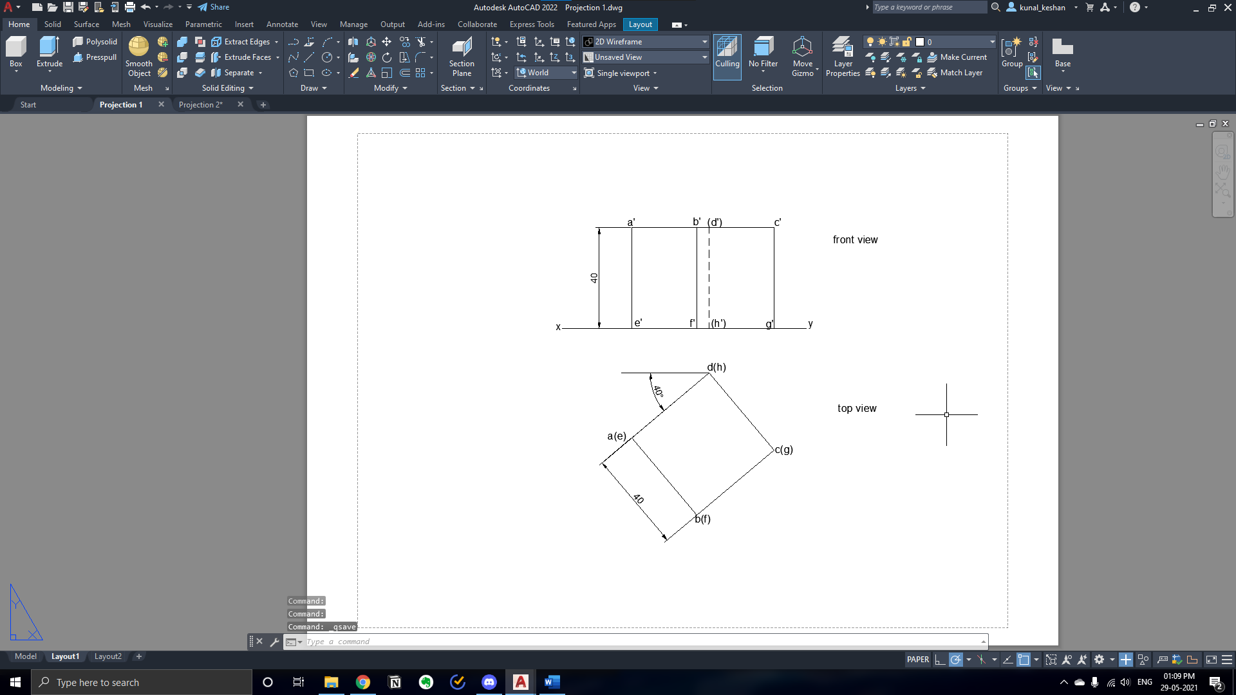

**Question 2:**

A square prism of base side 35 mm and axis length 60 mm lies on the ground on one of its longer edges with its faces parallel to the wall. Draw the projections.

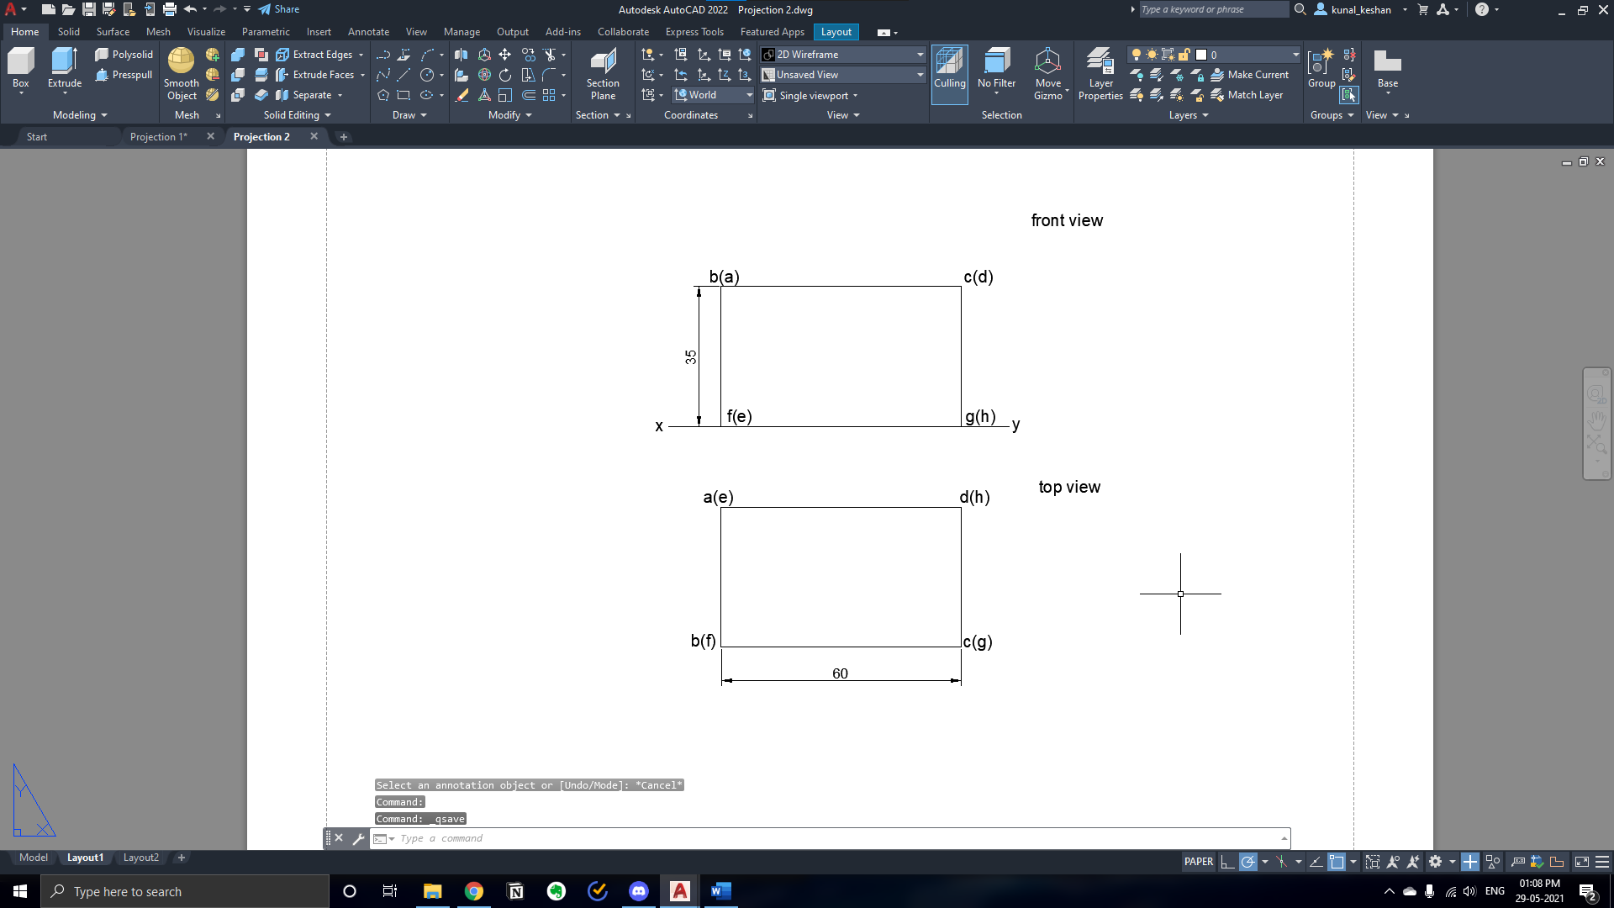

**Questions 3:**

A hexagonal prism of base of side 30mm and axis 60mm rests on the ground on its base with a base side parallel to wall. Draw the projections of the prism and determine the true length of its longest diagonal.

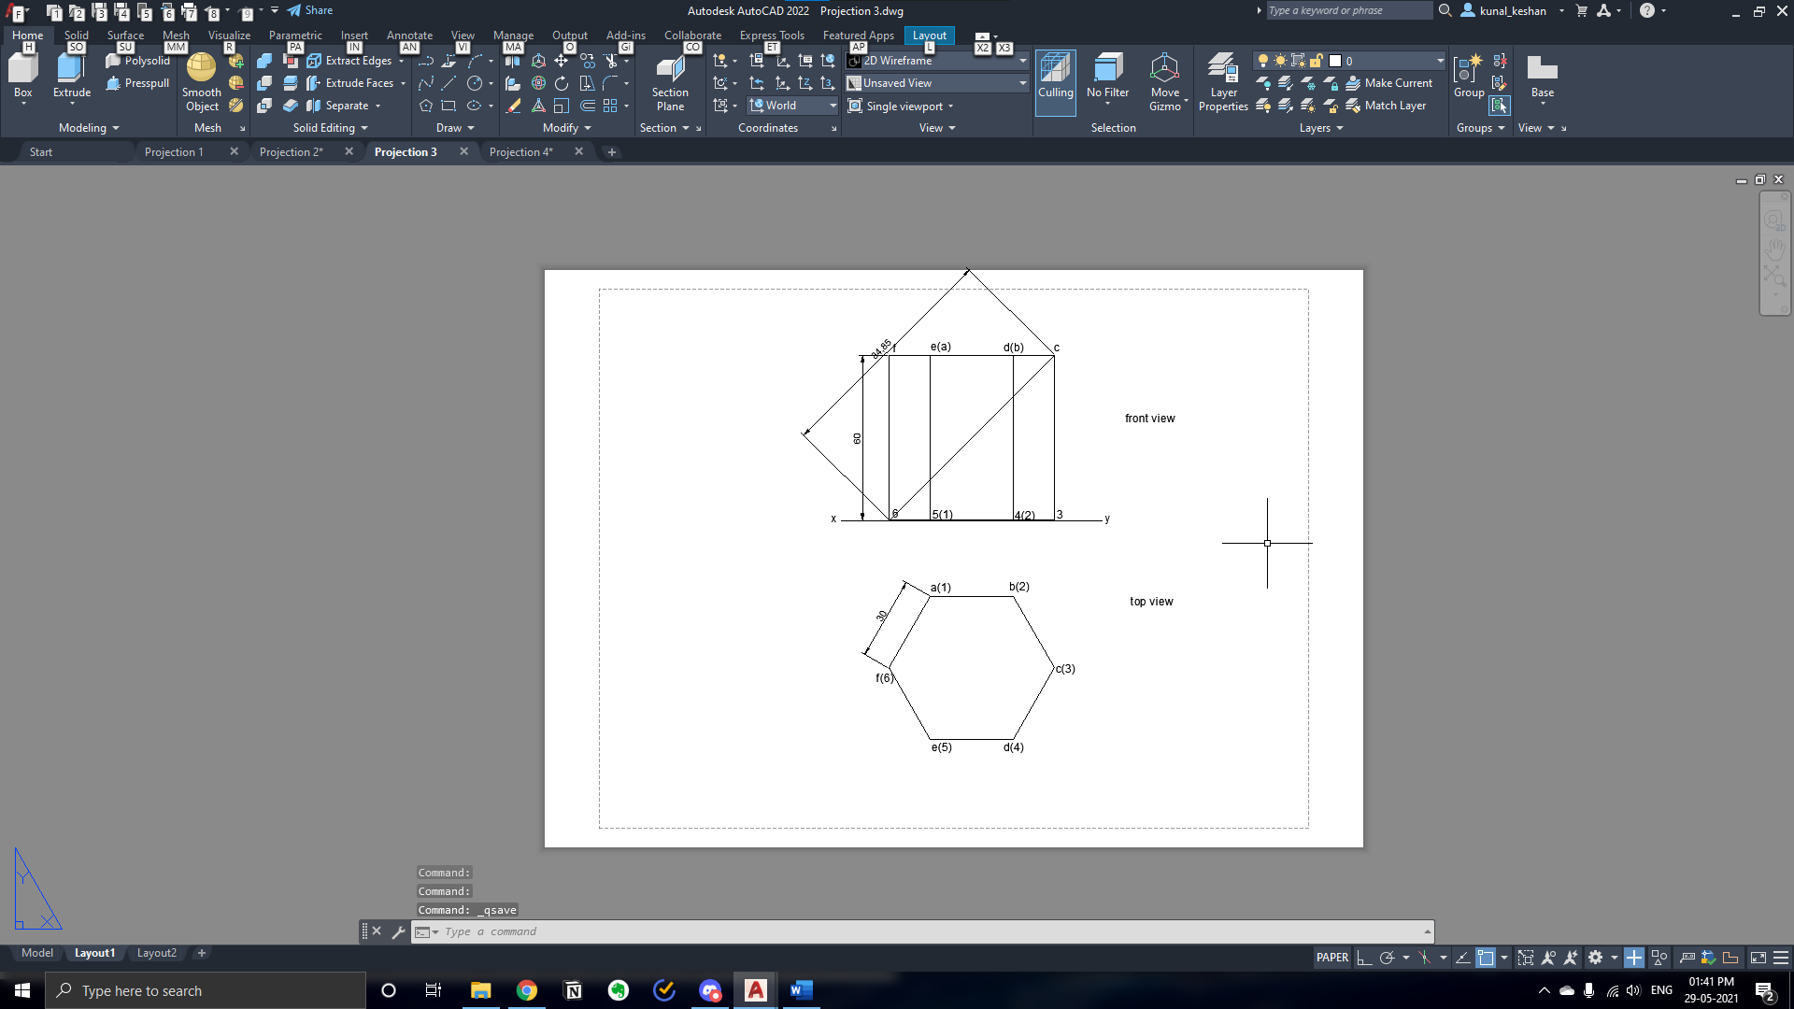

**Questions 4:** Draw the front, top and, right side views of a pentagonal prism of base side of 20 mm axis 35 mm when it is resting on the floor on its base with one of the edges of the base inclined at 30o to the wall.

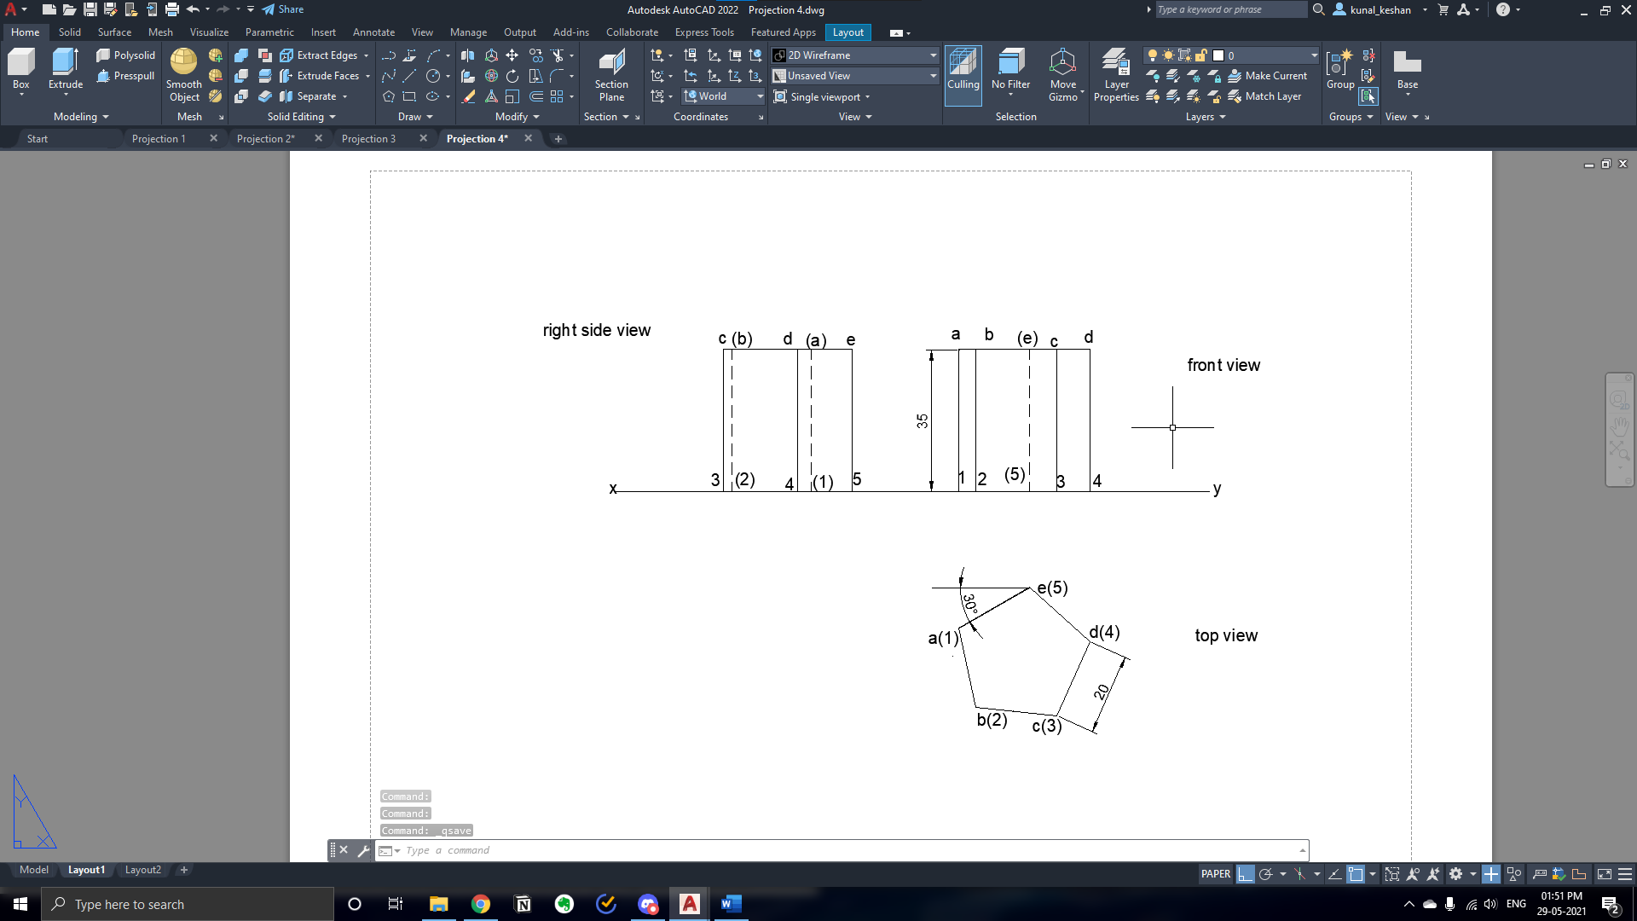

**Result:**

The projection of solids has been drawn with the required dimensions.